5th March 2022
Lake Manuwai Waipapa
Kaihoe O Ngati Rehia Trust - Waka Ama Club
Final Panui

EVENT SUMMARY

Kaihoe O Ngati Rehia Trust invite you all to participate in our 3rd Lake Series ‘Dirty Dozen’. Each series race day is designed to accommodate and assist paddlers and coaches to prepare for the next big event coming up, in this particular case, we have had a request to run a w12 race day.
The course is designed to be inclusive to Novice as well as seasoned paddlers.
Lake Manuwai has a unique contour, in which we can incorporate short, medium or long distance.
The water is divine and the spectators (when allowed) can take in the action for most part of the event.
The event is a full day of fun racing, live music and good vibes.
This is a My Vaccine Pass only event. NO spectators and NO children!
We welcome you to join us for this event.

EVENT SCHEDULE

7.00am | Registration, waka drop off & safety checks
9.00am | Karakia
9:15am | Race & safety briefings
9.30am | Racing Starts
2pm | Racing finished
2:15pm | Closing Karakia

RACE SCHEDULE

9:30am | Race
W12/W1 | ALL IN 3000m Blow of the Cobwebs - Open Men / Open Women / Open Mixed
W12 | 4000m - Open Men / Open Women / Open Mixed
W12 | 500m Sprint - Open Men / Open Women / Open Mixed
W1 | W1 500m Sprints - Open Men / Open Women / Open Mixed
W12 | W12 2000m Turns - Open Men / Open Women / Open Mixed

RACE DAY INFORMATION

Car Parking: Parking is available in the reserve on site. Please note NO parking in the lake driveway. The parking wardens will instruct where to park, please keep the driveway clear.
Trailer parking: Trailer parking will be in front of the shed, as per normal.
Food: We encourage you to bring your own healthy kai.
Toilets: Toilets are located at the far end of the driveway, by the shed past the main registration tent.
First Aid: First Aid will be available at the registration tent, via main driveway.
Rubbish/Recycling: We encourage you to please take what you bring. However, there will be rubbish and recycling stations located on site.
Alcoholfree/Smokefree: Alcohol, smoking, vaping and any other substance use is not permitted at this event, including all premises of the event.

WAKA DROP OFF & SAFETY CHECKS

Waka Drop off:
- Waka drop off will be available from 7.00am on the event day.
- Waka drop off will be down the right of the drive, by the shed.
- Trailer parking is in the same place as drop, please be aware of your surroundings and park side by side.

Safety Checks:
- All waka will have to pass a safety check and be marked before racing. Any boats not marked
will not be permitted to race.

RACE RULES

All entrants must be familiar with the Waka Ama New Zealand race and safety rules.
Refer to the following link for more information: http://wakaama.co.nz/pages/read/1003423

AGE DIVISIONS & RACE EVENTS

WAKA | DISTANCE | DIVISIONS
W12 | 3000m  4000m  500m Sprint  2000m Turns | Open Grades - Men, Women, Mixed
W1 | 3000m  500m Sprint | Open Grades - Men, Women, Mixed

FEES

Division | Cost
Cost per Kaihoe | $10.00
ONLINE ENTRIES & PAYMENT

- Online entries are to be completed using the Waka Ama NZ online entry system. https://www.wakaama.co.nz/racecalendar/lookup/1984
- All entries to be completed through your club admin – contact your club admin to process your entry.
- No entries on the day, no exceptions.
- Entries close on Tuesday 1 March 2022.
- Rosters close on Wednesday 3 March 2022. Rosters must be completed by close date, no exceptions.
- Once entered, payment can be made online to:
  - Kaihoe o Ngati Rehia Trust
  - 12-3091-0219174-00
  - Use your club, team name and division as your reference

SAFETY REQUIREMENTS

- All waka must be Safety Checked
- All Junior (J16 & J19) and Senior (Open and above) must have the following safety equipment for their races:
  - PFD - Personal Floatation Device (per person)
  - Bailers
  - Flare or cellphone in waterproof case
  - Spare Paddle - 2 for a W6, 1 for W1/2
  - Spray Skirt (W6)
  - Tow Rope (W6)
  - Leg leash (for sit on top W1)

COVID-19 INFO

- All attendees will need to scan their vaccine passes and sign in using QR codes provided for the event. A manual sign in sheet will be provided at the registration tent.
- Sanitizing stations will be set up next to the registration tent. Please use these frequently.
- This event is subject to cancellation or postponement depending on Covid levels
- Where possible, please do not share equipment
- If you are sick, have been feeling unwell, or have travelled overseas recently, please stay home

INDIVIDUAL & TEAM WAIVERS

- Individual and Team waivers must be completed by all paddlers/teams.
- All paddlers U18 must have their waiver signed by their parent/guardian.
- Individual & Team waivers can be found at the link below. Please download and return completed forms to Sophia Thomas at kaihoengatirehia@gmail.com or you can hand them in at the registration tent on the day.

Kaihoe o Ngati Rehia Trust Pearl of the North - Lake Series Team Waiver
Kaihoe o Ngati Rehia Trust Pearl of the North - Lake Series Individual Waiver

CONTACT INFORMATION

- All enquiries please email: Uncle Danny or Sophia kaihoengatirehia@gmail.com
- All urgent matters please call: 02102462475
- Facebook: https://www.facebook.com/groups/156538157714816

COURSE MAPS

Map 1: 3000m Race Course ‘Blow Out The Cobwebs’
Map 2: 4000m Race Course ‘Motu to Motu’.
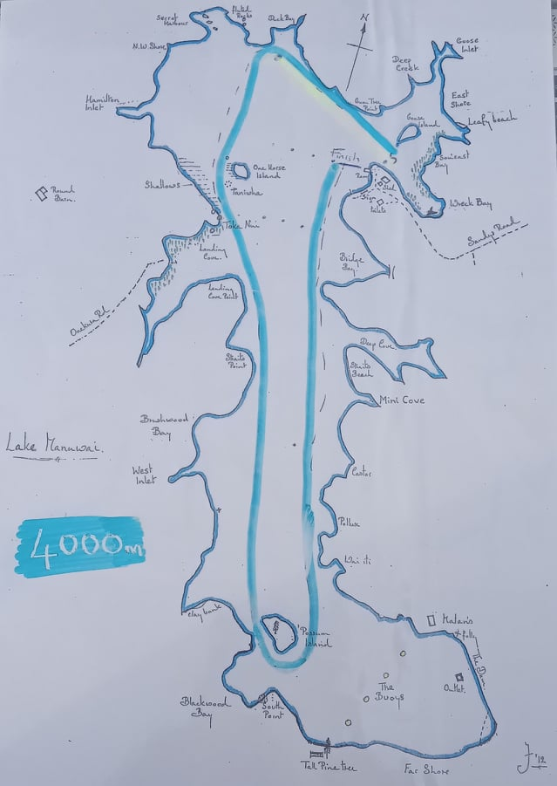
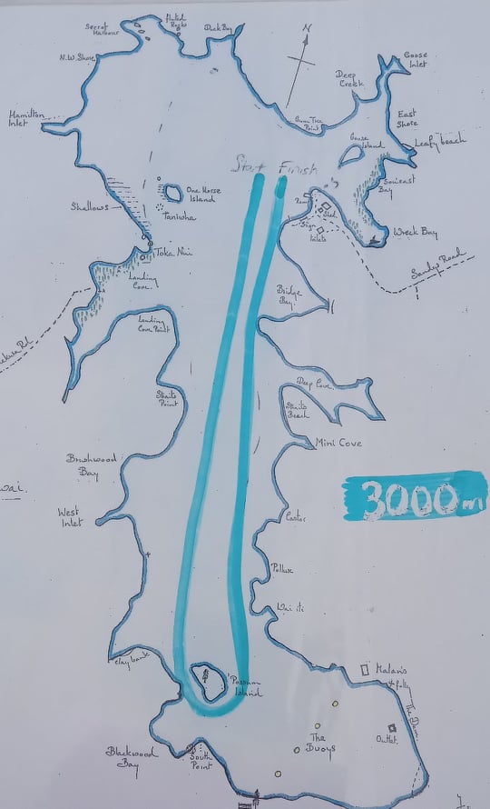

Map 3: 500m Race Course for Sprints and 2000m Turns.
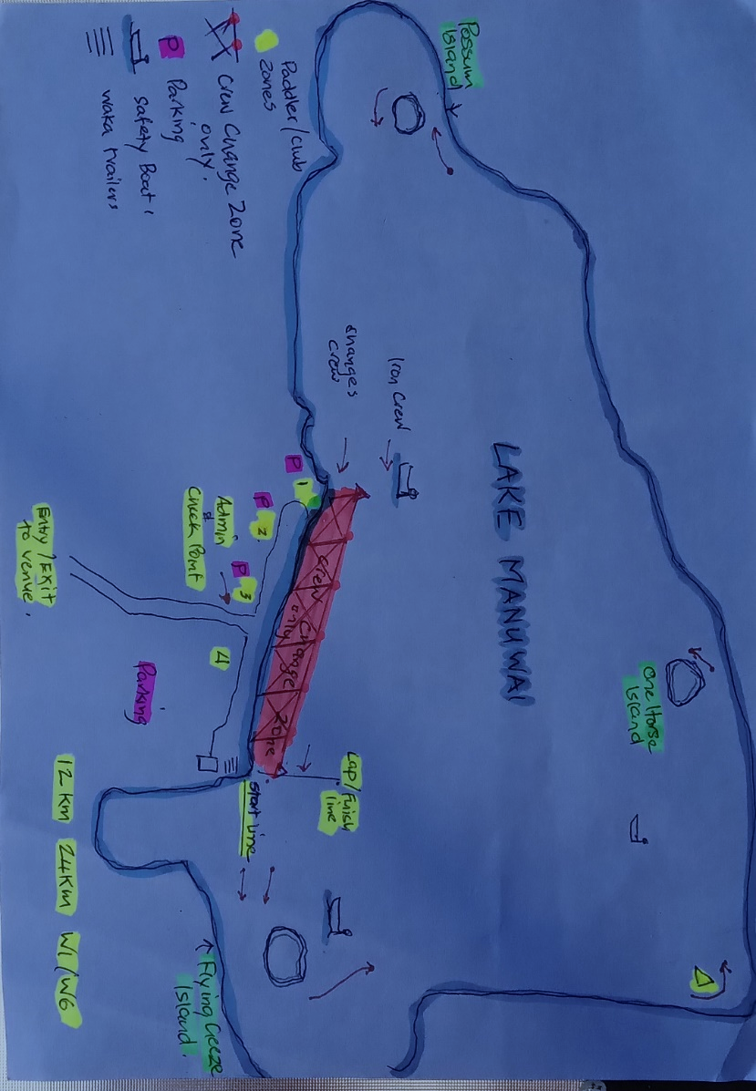
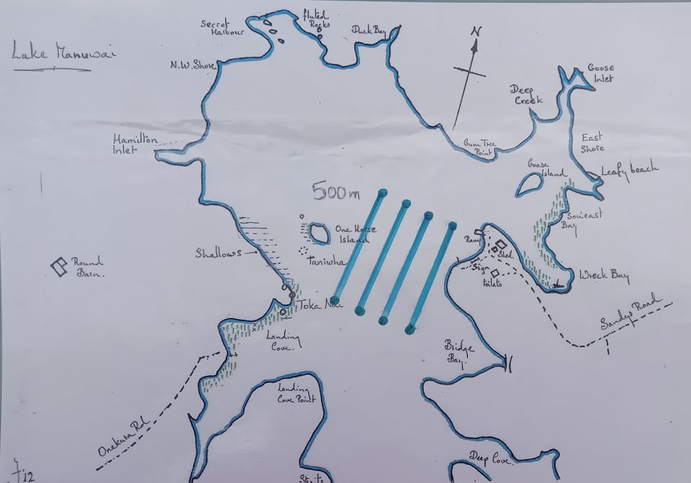

Map 4: Just an example of our on land set up. It is the same as our last two red light events and found that it really worked well.

